

**CSE 499- Thesis/Project/Internship**

**Term: Fall Year: 2020**

|  |
| --- |
| **Name: Mohammad Navid Nayyem** |
| **ID: 172014003** |
| **Contact Number: 01724463611** |
| **ULAB Email Address: navid.nayyem.cse@ulab.edu.bd** |
| **Alternative Email Address: navidnayyem@yahoo.com** |
| **Current CGPA:** 3.61 |
| **Supervisor choice:**  **1. Mohammad Rifat Ahmed Rashid**  **2. Abul Kalam Al Azad**  **3. Mohammad Shahriar Rahman**  **4. Muhammad Golam Kibria**  **(We want to do our capstone project under “Mohammad Rifat Ahmed Rashid” Sir.)**  ***It is not guaranteed that any of the above faculty members will be your supervisor.*** |
| **Are you taking internship? If so, state the name of the organization and your role in the organization** |

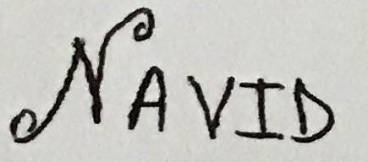**02-11-2020**

**Signature with date**